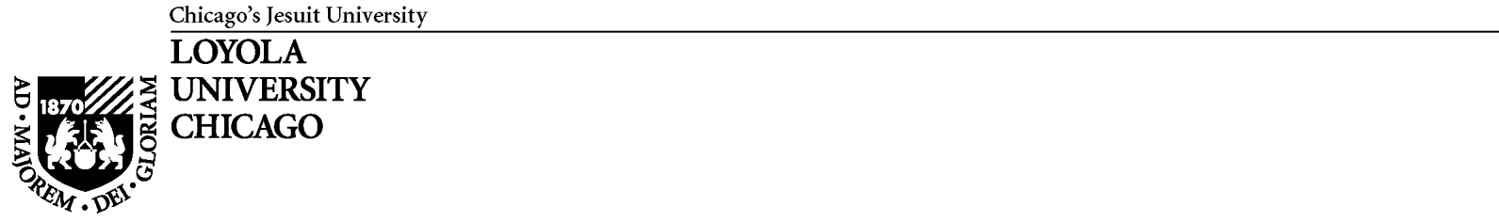
Radiation Safety Training Record Form

Radiation Training Record for (please print)

Check one: undergraduate student
graduate student
B.S./M.S. level technician/research associate
postdoctoral appointee
visiting scientist
other (please explain)

After 1 hour of supervised training by the Authorized User or other fully trained supervisory research personnel, lab members are allowed to handle exempt quantities of isotope. This includes up to 1 mCi ³H, 0.1 mCi ¹⁴C or ³⁵S, 0.01 mCi (10 μCi) ³²P, and 1 μCi ¹²⁵I (for other isotopes, contact the RSO). For unsupervised handling of greater quantities, five hours of recorded, supervised training are required. Under no circumstances are undergraduate students or non-Loyola affiliated personnel allowed to handle in excess of 10X exempt quantities. You may wish to submit this form twice, once when the lab member completes one hour of training and again after five hours of training.

Date | Hours of handling | Isotope | Quantity handled  (μCi) | Signature of Super-  vising Researcher

The above named person has completed the appropriate number of hours of supervised training for their research needs, is competent to work unsupervised on approved protocols, and has been informed of their personal user restrictions.

Signature of Authorized User Date

Name of Authorized User (please print)

Please make a copy for your records and forward the original to the Radiation Safety Officer, Howard Laten, Biology, LSB325.

